How Paintballs are Made

By: Ryan Kauler

November 12, 2006

MEEG 453

In the following report you will gain insight in the manufacturing process of paintballs. Playing the sport of paintball for many years, I often wondered how they were made. It is really amazing how much quality control and material handle that goes into this manufacturing process, so that this messy item has a relatively clean process. The first part of the report will go into the detail of the manufacturing process and inform you of the many steps that are involved. The following will discuss the business aspect of the industry and what economic factors are involved in paintball manufacturing. Lastly the report will talk about the processes relevance to beginning and mature engineers, and what I learned about from my research on this topic.

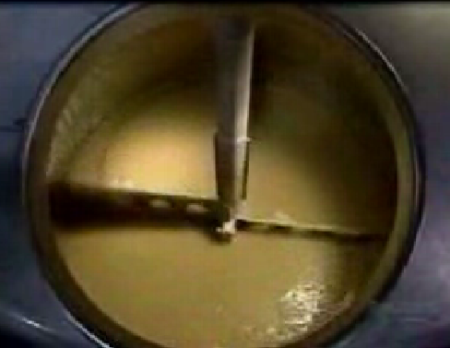
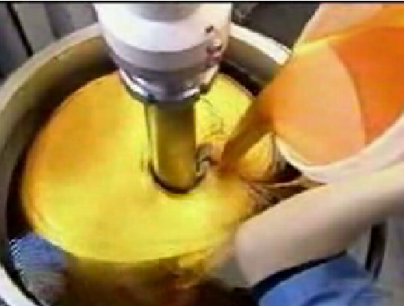
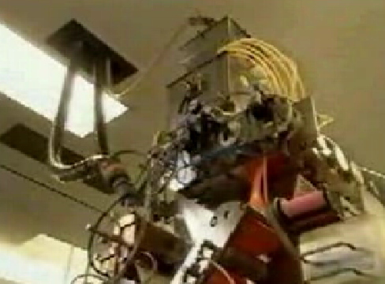
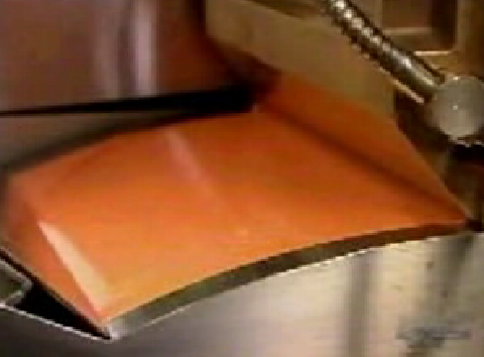
Discussion: How Paintballs are made
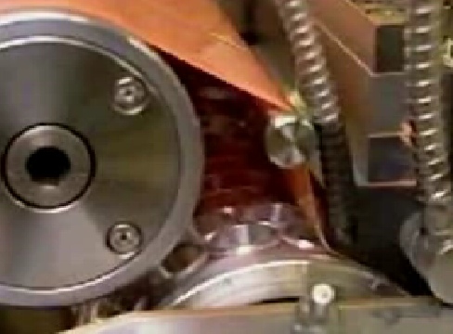
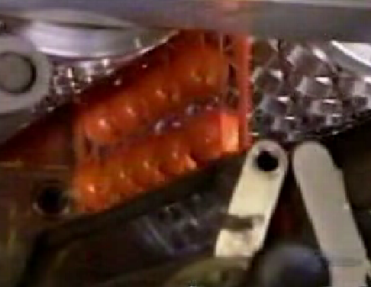
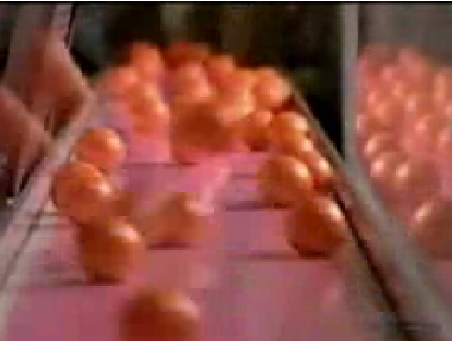
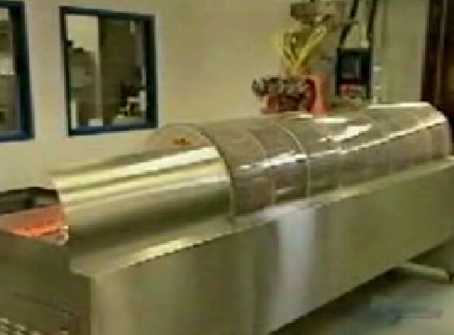
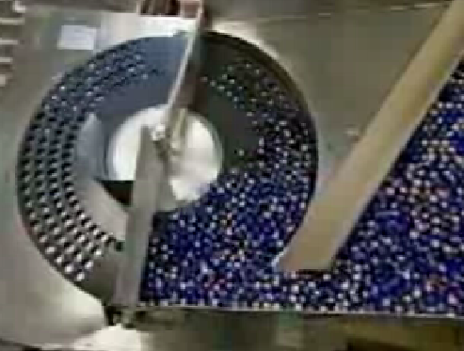
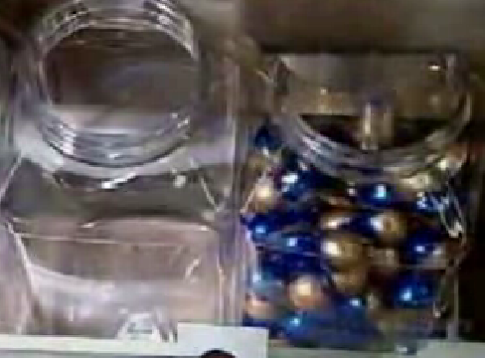
The sport that millions of people enjoy worldwide has expanded rapidly in its only 20 year old history. The manufacturing processes are really amazing and very highly automated because such a great number of them have to be produced as cheaply as possible. Paintballs are made entirely of non-toxic food grade ingredients. The first part is to make the gel that is later turned into the shell. The process starts out in a large heated mixing bowl where water, sweeteners, some other secret substances and the key ingredient gelatin are melted and blended together for a half hour. It is then transferred into a heated vat through a filter, which is used to catch any globs that didn’t melt. Once the vat is filled a giant blender is lowered and food dye is added, it is then blended together for about another 20 minutes. At this same time the “fill” of the paintball is being made in a similar mixing vat. This “fill” is the substance in the paintball and is produced from polyethylene glycol, the base substance in cough syrup, crayon wax, and food dye. The gel and fill are then transferred by a series of tubes to the capsulation machine one floor below. The machine is also the same kind used to make the shells of gel capsule medication with a slightly different tooling for the desired size and shape of a paintball. The gel is spread out onto a cool drum that will harden it slightly producing a continuous sheet of gel called a gel ribbon. This process is critical because it cures the gelatin so that it can later be molded into the hard shell of a paintball. The machine then presses the gel ribbon into a half sphere shaped dye. This next part is by far the trickiest part of the process. The half sphere is met up with an adjoining sphere on the other side and simultaneously injected with the “fill” and sealed together. Often paintballs are two colors, this can be done with the exact same process but one side of the capsulation machine is fed with a different color gel. The balls are then removed from the excess gel ribbon by two rollers and transferred by conveyor into a tumble dryer. The paintballs are still very soft because the gelatin of the shell is still warm, so the tumble dryer is used so that the balls will harden but also so maintain their round shape which is very important in paintballs or they will not feed right in a paintball gun. Once they exit the tumbler they are transferred to a bakery style rack where they will dry out completely. They are then transferred to a counting machine that will count out a preset quantity of paintballs and drop them into a container that is then sealed labeled and sent out to the stores.

Business Aspect: The Importance of Quality Control
As you can see from the above explanation, the making of paintballs is extremely automated. This is due do the very great numbers of paintballs that have to be made as cheaply as possible to stay in the very competitive market of the paintball industry. The quality control that the different paintball manufactures have directly affects the success of the company. I know personally that when playing paintball everyone knows what brand or brands of paintballs are the best. The quality significantly affects the range and accuracy of a fired paintball. The quality of a paintball is mainly determined by the size and roundness of the ball. The standard size of today’s paintballs are .68 caliber. This size however often ranges in the area of .681 to .696 calibers because paintballs tend to be slightly thicker at the seam where the two halves were joined together. Small paintballs could simply roll out of the barrel causing a misfire or in most cases the air will simply blow by the ball when fired and result in a poor firing distance. On the other side if a ball is too large it can cause gun jams or in worst case break inside the barrel causing a big mess and puts the player’s gun out of order until the broken ball and fill can be cleaned from the gun. In the case of paintballs I could see a “GO” or “NO GO” quality assurance checkpoint being very effective. Simply pass them through a series of sieves to get the desired ball side. Quality paintballs will also have a durable shell that will not break in the packaging, because one broken paintball can ruin all the ones that come into contact with the fill. Also the shell has to be the right mixture so that it will break on contact during the actual paintball game. No one would want a paintball that when fired at a target it just bounced off instead of spattering. The right balance between these two shell characteristics is key. Seeing how greatly the quality of a ball affects the overall end user satisfaction would lead ball manufactures to have very strict quality control systems or checkpoints. If their quality control lacks they will loose many customers because word spreads fast at paintball fields.

Relevance for Beginning and Mature Engineers
The major significance of this topic for a beginning engineer is that simple items can have a very complex manufacturing process. A small paintball that consists of only a shell and fill has to go through many steps before it is shipped out to the consumers. Some of the process are very simple whereas the filling and sealing of the balls is very complex and requires a highly engineer system. However putting the form filling and sealing all into one step probably saved a lot of cost in machinery and material handling. So a novice engineer should remember to keep the process as simple as possible and realize that most manufacturing processes are probably more intensive then one would think.
A Major significance of this topic for a mature engineer is to remember the importance of quality control and build that into your manufacturing processes. In this area of business as stated above the quality of the paintball is severely important. If the right gel mix is not used the shell properties can change drastically from being a good paintball and being a bad one. The size of the ball on the order of thousandths of an inch can greatly affect the quality and performance of the ball. So remember good quality will lead to a happy paintball customer, and bad quality will make him switch brands in this very competitive market.

Learning
I learned that a simple item consisting of just 2 parts could have a very complex and expensive manufacturing process. I believed that the shells were made first and hardened then just filled with the “fill”. Then I learned how the whole process really works with the formation of a gel ribbon and then the amazing form, fill, and seal of the paintball by just one step. I realized that even though that one step essentially made the ball there was way more steps before and after, that are very important as well. I then learned that the manufacturing process is generally much more complex then I originally expected it to be.

Works Cited

How Paintballs are Made
http://www.sudden-impact.co.uk/howpaintballsaremade.html

Paintball Facts
http://www.ottersccustoms.com/paintu.html

Birth of a Paintball
http://lennon.csufresno.edu/~nas31/nsa/birthpaint.html

